ETL Tools

ETL stands for Extract, Transform, and Load.
It is a process used to collect data from different sources, clean and organize it into a useful format, and then store it in a central system like a data warehouse for analysis and decision-making.

ETL tools make it easier for organizations to turn raw data into meaningful information.

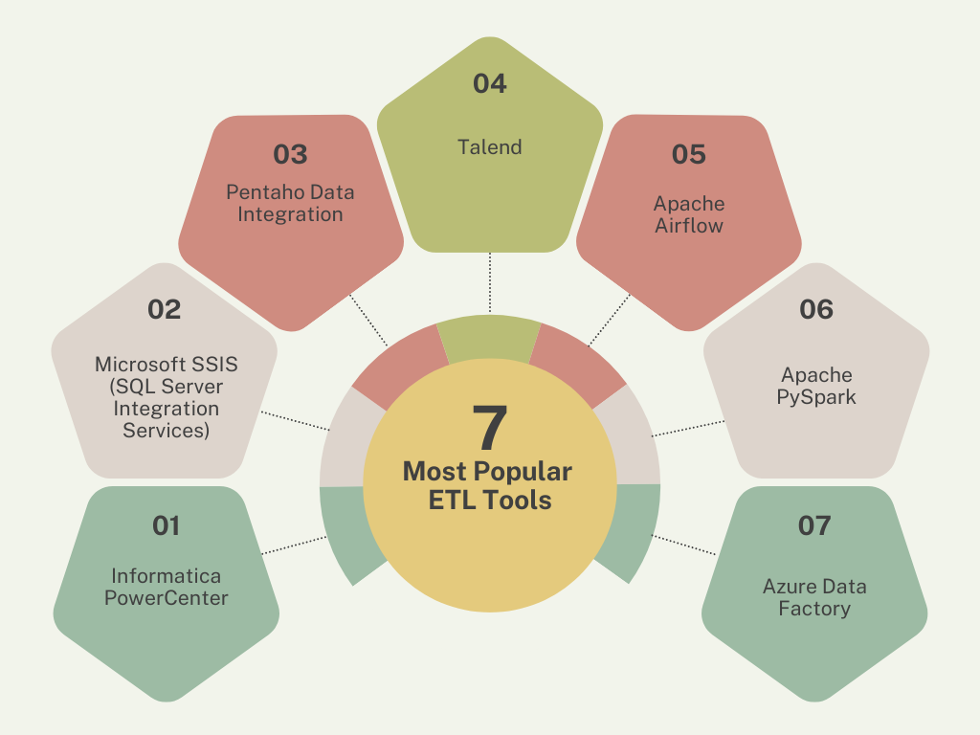

1️⃣ Informatica PowerCenter
Informatica PowerCenter was introduced to support large enterprises that work with huge and complex data systems.
Companies needed a stable and secure platform to integrate data from multiple sources.
It uses Java, SQL, and metadata-driven architecture and is mostly used in banking, telecom, healthcare, and insurance industries.
Advantages:
- Handles complex transformations
- Highly scalable and secure
Disadvantages:
- Expensive licensing
- Not suitable for small businesses

2️⃣ Microsoft SSIS (SQL Server Integration Services)
SSIS was introduced by Microsoft to provide ETL support inside the SQL Server ecosystem.
It helps companies easily move data between databases, files, and reporting tools.
It uses SQL Server, .NET, C#, and Visual Studio and is popular in Microsoft-based organizations.
Advantages:
- Easy to learn
- Integrates well with SQL Server and Power BI
Disadvantages:
- Mostly Windows-based
- Not ideal for big data
3️⃣ Pentaho Data Integration
Pentaho was introduced as an open-source ETL solution to make data integration affordable.
It is designed for small and medium-sized businesses.
Built using Java and SQL, Pentaho is widely used in retail and manufacturing sectors.
Advantages:
- Open source
- Supports many data formats
Disadvantages:
- Performance issues with very large data
- Limited enterprise features

4️⃣ Talend
Talend was introduced to provide a powerful yet user-friendly ETL platform.
It bridges the gap between open-source tools and enterprise ETL solutions.
Talend is built using Java, with strong support for cloud, big data.
It is used by startups, data integration teams, and cloud-based companies.
Advantages:
- Easy to use graphical interface
- Supports cloud and big data integration
Disadvantages:
- Performance tuning can be complex
- Enterprise features require paid versions
5️⃣ Apache Airflow
Apache Airflow was introduced to schedule and monitor data workflows.
Instead of running ETL jobs manually, Airflow automates and tracks pipelines.
It uses Python and DAG-based architecture and is popular among data engineers.
Advantages:
- Excellent workflow management
- Flexible and scalable
Disadvantages:
- Requires Python knowledge
- Setup can be complex

6️⃣ Apache PySpark
PySpark was introduced to handle large-scale data processing efficiently.
Traditional ETL tools couldn’t manage massive datasets fast enough.
It is based on Apache Spark, Python, and Hadoop and is used in big data, AI, and streaming platforms.
Advantages:
- Very fast processing
- Handles huge datasets
Disadvantages:
- High memory usage
- Debugging is difficult

7️⃣ Azure Data Factory
Azure Data Factory was introduced to support cloud and hybrid ETL workloads.
As businesses moved to the cloud, they needed an automated data integration service.
It works using Azure services, REST APIs, JSON, and is used by Azure-based enterprises.
Advantages:
- Fully managed and scalable
- Integrates with Azure ecosystem
Disadvantages:
- Azure-dependent
- Limited transformation capabilities

